**Assignment 1: Class Simulation**

* C# coding:
* **C# coding in folder :** [**12520250@gm.uit.edu.vn\BTNB\Ass1_12520250@gm.uit.edu.vn\C#_Coding\**](mailto:12520250@gm.uit.edu.vn\BTNB\Ass1\C#_Coding\opt1_Assignment1_Stack)**opt2 _Class Simulation**
* Test:
* C# coding: coding in ‘main’ function in file ‘Program.cs’
* Result:

+ Run 1:

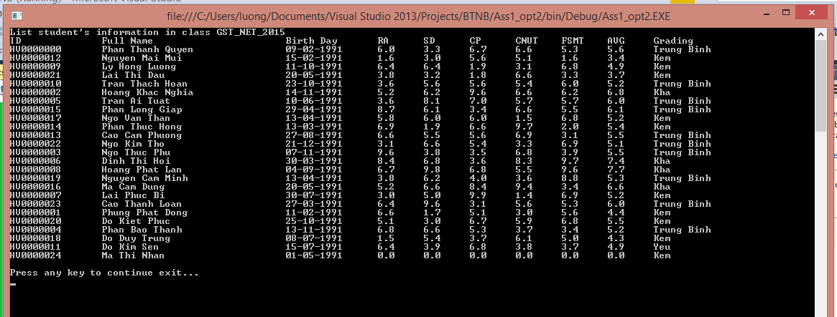

+ Run 2:

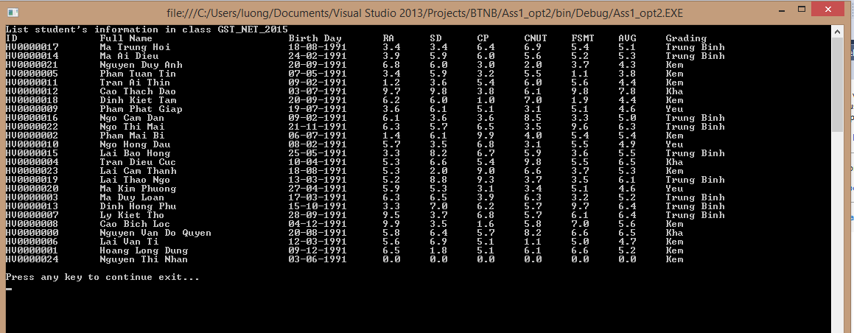

+ Run 3:

